Electronics Assembly and User Guide

- Parts List

Part | Image | Description
Power Board |  | Regulates power to electronics, motors and servos. Home to radio module, power connectors and data cables.
Slug |  | Houses the main processor. USB ports for file system and webcam. Connects to power board using ribbon cable.
Motor Board |  | This board controls the main drive motors
Joint IO Board |  | Digital/analogue inputs (bump/position sensors) connect to this board.
PWM Board |  | Servos connect to this board.
6 Data Cables | - | Connects Motor, JointIO and PWM boards to the Power Board
USB Memory Stick | - | Stores Program code and operating system
Web Camera | - | Provides input to vision system
PCB Standoffs | - | Bag of metal stand-offs with screws to securely mount boards to robot
Power Connectors | - | Insulated connectors for making connections to the terminals on the Power Board
Battery Charger | - | Mains powered battery charger.
Electrical Wire | - | Many coloured lengths of insulated electrical wire
Table 1.1 – List of electronic modules and kit supplied
- Basic Configuration
  - Connections to Motor Board

The (black) data cables are used to connect the Power Board to the PWM Board, Joint IO Board and the Motor Board. Connect each board in turn to one of the four available sockets on the Power Board. The order does not matter.

Next, connect the Slug to the Power Board using the coloured ribbon cable. The socket is located at the centre of the Power Board (see Figure 2.11).

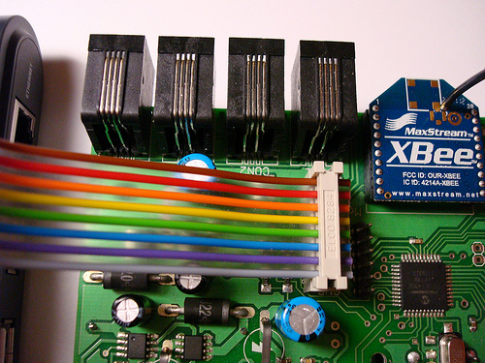

Figure 2.01 – Slug ribbon cable connected to Power Board.

Now insert the (orange) USB Memory Stick into USB port of the Slug labelled as ‘Disk 2’ (right-most USB port in Figure 2.12).

Connect the Webcam to the remaining, free USB port on the Slug; labelled as ‘Disk 1’.

It is important that the USB Memory Stick is inserted into the ‘Disk 2’ slot.

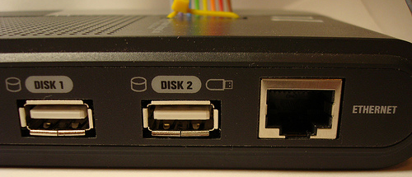

Figure 2.02 – Side view of Slug. USB Memory Stick MUST plug into ‘Disk 2’ slot

  - Power Connections

Using the Power Connectors and Electrical Wire supplied, make the following connections (see Figure 2.11):

- Connect LGP1 to LGP2 via the black SPST (Single Pole Single Throw) switch. This is the main power switch for the robot.
- Connect the positive terminal of the battery to BAT+. Connect the negative terminal of the battery to one of the GND terminals on the Power Board.
- Connect CGCOM to CHRG and CG-RN via the white single pole double throw switch (see Figure 2.12). In Charge mode (CGCOM connected to CHRG) the battery is charged and the motors are off. In Run mode (CGCOM connected to CG-RN) the motors are powered and battery stops charging. The electronics can operate in both of these modes, so that you can develop your robot whilst it is charging.
- Connect SERV+ on the Power Board to the +5V spade on the PWM Board. Connect GND on the Power Board to the GND spade on the PWM Board (Figure 5.0). This provides power to the servos.
- Connect MOT+ on the Power Board to the +12V spade on the Motor Board. Connect GND on the Power Board to the GND spade on the Motor Board (Figure 4.0). This provides power to the motors.

  - Safety

- Always remove the power supply before making ANY modifications to your robot.
- Stick to a colour convention for wiring. For example use Red for all positive connections and Black for connections to ground. This will help prevent accidental shorts that could potentially damage the electronics.
- Do not place the Power Board inside any metal enclosures as this will prevent the built in radio module from working.

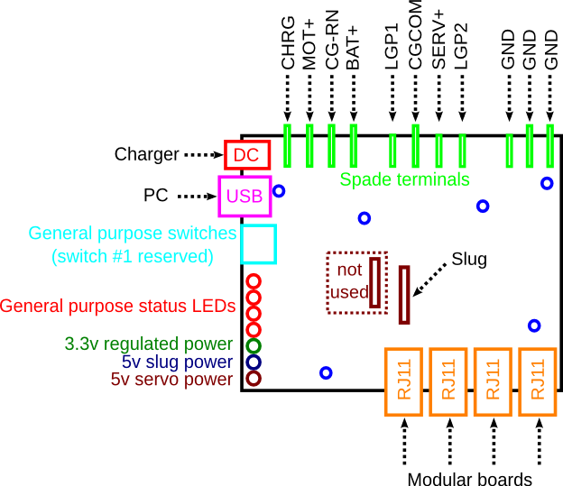
Figure 2.11 – Power Board Connections

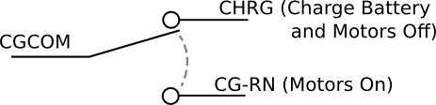
Figure 2.12 – Illustration of Charge/Run switch

- Joint IO Board – Analogue/Digital Inputs and outputs

The Joint IO Board provides 8 Analogue/Digital inputs and 4 digital outputs. The Inputs are numbered in ascending order from left to right in the diagram. To connect digital devices such as bump sensors (push switches), use the wire supplied to connect the terminals of the switch as show in Figure 3.1, with one to positive supply, and the other to one of the inputs.

Analogue inputs are connected in a similar way, illustrated in Figure 3.1 by the variable resistor which could be used to measure the position of an arm.

Finally, digital outputs such as LEDs can be connected to the Joint IO as illustrated in Figure 3.1. Note that it is necessary to place a resistor in series with the LED to reduce the current.

  - Safety

- Do not connect servos or motors directly to the Joint IO board because the large currents will damage the board. Instead, speak to your mentors/teachers about using a relay to switch the motor on and off.

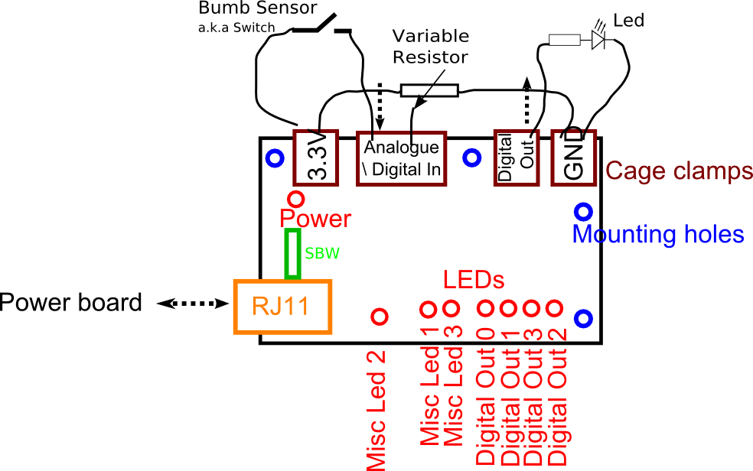
Figure 3.0 – Overview of Joint IO Board with bump sensor, variable resistor and LED connected

- Connecting Motors

The Motor board can control (with variable speed) two DC motors. The positive and negative leads from the motor should be screwed into the grey terminal blocks on the Motor board. It is recommended that you connect the two drive motors to the Motor Board.

If your design requires additional motors, e.g. for moving armatures, the power for these should be sourced from the motor rail off the Power Board. This is also true for any bespoke hardware (that needs to use the 12V battery supply) which you may choose to construct for your robot. This allows the power to be cut in the case of an emergency.

  - Safety
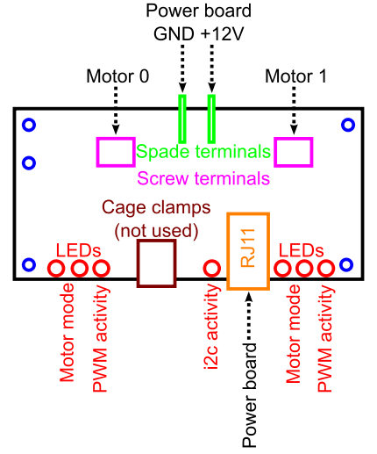Figure 4.0 – Overview of Motor Board
- Nothing should be connected directly to the battery (except for the power board!). This includes additional motors and circuitry. (see previous paragraph for instructions on connecting additional motors)

- Connecting Servos

There is provision for up to six servos to be controlled by the PWM board (the last two sockets on the board are repeated). Figure 5.0 illustrates how to connect them to the board. Pay close attention to the polarity.
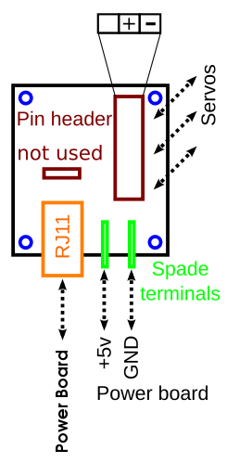
Figure 5.0 – Overview of PWM Board

- Miscellaneous

In addition to the digital inputs on the JointIO board there are also four switches on the Power Board. These switches can be read by your program. One of the switches selects whether your robot is in “competition” or “practice” mode. In competition mode, your robot will not run its code until signalled over radio. In practice mode, your robot's code will be executed on power-up. DIP switch number 1 will select between these two modes. When the switch is lowered (ON), the robot will be in practice mode.

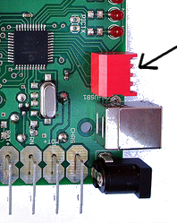
Figure 6.0 – Close-up of Switches on Motor Board

